GRADUATE INFORMATION NEEDED
Call the church office (239-8423) or email us at chestnuthillumc@comcast.net and let us know what school you will be graduating from and your plans for the future.
Flowers
The flowers placed in the Commons are in honor of Jeanette Almond’s 94th birthday (June 10) by her daughter, Carolyn Phelps.
Read Ahead
June 16, 2019 ~ Trinity Sunday. The Scriptures are Romans 5:1-5 & Psalm 8. The sermon text is John 16:12-15 and the message is “God Loves You So Much”.
In the Grocery Cart This Month
For JUNE: Soap and Body Wash; Deodorant; Shampoo; Adult and Baby Wipes; and Dish Detergent”. This will assist people through Park View Community Mission. Place donations in the grocery cart, located in the Commons.


Children and Their Safety are Important at Chestnut Hill UMC
We rejoice that as a church we are able to offer carefully planned, age appropriate care and activities for our children and youth.
Today, children ages 6 and above will stay in the sanctuary for worship.
The Nursery for infants up to age 6 is located in Classroom 101 (exit through the right side door at the front of the sanctuary, pass through “the Commons,” go through the double doors to the Education Building and follow the hallway to the
Nursery at the end of the hall on the left).

DIRECTORY OF CHESTNUT HILL UNITED METHODIST CHURCH
 | Sharma Lewis | Richmond Area Resident Bishop
 | Peter D. Weaver | Interim Bishop
 | Scott Davis | Lynchburg District Superintendent
 | Liz Ecklund | Minister
 | Vernie Barrow | Minister Emeritus
 | Monica Campbell | Administrative Assistant
 | Heather Wilson | Director of Music Ministry
 | Judy Martin | Bookkeeper
 | Judy Robertson | Lay Leader
 | Erin Ecklund | Nursery Supervisor


Chestnut Hill
United Methodist Church

Making disciples of Jesus Christ
for the transformation of the world.
You are welcome at Chestnut Hill UMC.

4660 Fort Avenue ~ Lynchburg, Virginia 24502
Church: 434-239-8423
Pastor’s Cell: 434-258-2934; Pastor’s Home: 434-319-5646
Email Pastor Liz: Pastorliz@aol.com
chestnuthillumc@comcast.net ~ on the web at chestnuthillumc.net
Find us on Facebook: Chestnut Hill United Methodist Church

Chestnut Hill United Methodist Church
10:30 a.m. ~ June 9, 2019 ~ Pentecost
Our ministry vision for the Virginia Annual Conference is “to be disciples of Jesus Christ who are lifelong learners, who influence others to serve.”
Welcome! Join us in worshiping God!
Welcome and Ministry Announcements
Welcome in the name of Christ our Lord. Please register your attendance,
printing your name, address, phone, and email, when the pew pad is passed to you.
Thank you for silencing cell phones as we gather to worship God.
Invocation
Prelude “There’s A Spirit in the Air” arr. McConnell
*Call to Worship
Let us come together, all whose lives would proclaim God's glory!
We open our hearts this day to God's presence and power.
In our prayers we lift all that we are before the Lord.
With courage we will do and share God's love with the world.
Let our voices be raised in praise and song to the glory of God!
Blessed be the name of the Lord!
*Singing Our Faith # 545 “The Church’s One Foundation”
Morning Prayer
O God, You alone are to be praised. We sought Your mercy, and You also extended Your grace. We seek to serve You, and You empower us with Your gifts. Fill us, O Lord, with Your presence. In Christ we pray. Amen.
Choral Anthem “The Longer I Serve Him” arr. Hamby
Prayer for Illumination Frances Unruh
O God, in Your mercy and Your grace You demonstrated Your love for us through the life of Christ. Help us to hear and see where You would have us spread Your love, O Lord. In Christ we pray. Amen.

Gospel Lesson John 14:8-17 (CEB) Frances Unruh
New Testament Lesson Acts 2:1-21 (CEB) Frances Unruh
The Word of God for the people of God.
Thanks be to God.
*Singing Our Faith # 2272 “Holy Ground”
The Good News “Wind & Spirit”
The Giving of God’s Tithes and Our Gifts
Prayer of Thanksgiving
Offertory “It Is Well” arr. Hamm
*Doxology # 95 Praise God from whom all blessings flow; praise him, all
Creatures here below; praise him above, ye heavenly host; praise Father, Son, and Holy Ghost. Amen.
The Prayers of the People
The Lord’s Prayer
Our Father, who art in heaven, hallowed be thy name. Thy kingdom come,
Thy will be done on earth as it is in heaven. Give us this day our daily bread and forgive us our trespasses, as we forgive those who trespass against us. And lead us not into temptation, but deliver us from evil. For thine is the kingdom, and the power, and the glory, forever. Amen.
*Singing Our Faith # 393 “Spirit of the Living God”
*Blessing and Dismissal
*Postlude
Scatter to Serve God & Neighbor
Welcome to all! We gather to praise God for the innumerable blessings given to us and to grow deeper in the Spirit. Joyfully, let us lift our hearts to God.

**This Week’s Calendar**

Sunday, 6/9 | 3:00 p.m. | District Conference Orientation  (CHUMC fellowship hall)
Monday, 6/10 | 9:30 a.m. | Bible Study
 | 6:30 p.m. | Wesleyan Group (Betty Taylor’s home)
Tuesday, 6/11 | 9:00 a.m. | Prayer Group
 | 7:00 p.m. | Homeschool First Game Night
Thursday, 6/13 | 6:45 p.m. | Choir
** Looking Ahead on the Calendar **
Sunday, 6/16 |  | Honoring Our Graduates Sunday
Monday, 6/17 |  | Article deadline for combined July/August newsletter.
Thursday, 6/20 -  Saturday, 6/22 |  | Virginia Annual Conference ~  Roanoke, VA
Tuesday, 6/25 | 6:15 p.m. | Finance Committee
 | 7:00 p.m. | Administrative Council
Wednesday, 6/26 | 11:00 a.m. | Top of the Hill  Mona Thomas, Music Director at The Well Church, will present a program of music. Join us in welcoming Mona and sharing good fellowship together. Bring a sandwich. Drinks and dessert will be provided.
In Hospital: Beverly Franklin, Lebanon VA Medical Center (Lebanon, PA)
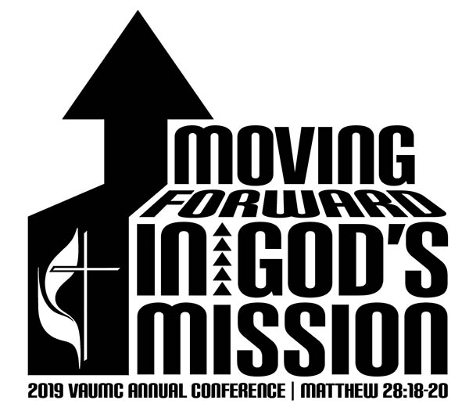
Virginia Annual Conference Offering
The offering goal is $150,000 and recipients will be:
Africa University Student Scholarships -- $40,000
Cambodia Pastors Leadership Training -- $40,000
Mozambique Lay Leadership Training -- $20,000
Brazil “Shade and Fresh Water” children’s program -- $20,000
Just Neighbors Matching Funds Grant for Immigrant Legal Counsel in four districts -- $30,000.
**Use a pew envelope and mark it “VA Annual Conference”.

**This Week’s Calendar**

Sunday, 6/9 | 3:00 p.m. | District Conference Orientation  (CHUMC fellowship hall)
Monday, 6/10 | 9:30 a.m. | Bible Study
 | 6:30 p.m. | Wesleyan Group (Betty Taylor’s home)
Tuesday, 6/11 | 9:00 a.m. | Prayer Group
 | 7:00 p.m. | Homeschool First Game Night
Thursday, 6/13 | 6:45 p.m. | Choir
** Looking Ahead on the Calendar **
Sunday, 6/16 |  | Honoring Our Graduates Sunday
Monday, 6/17 |  | Article deadline for combined July/August newsletter.
Thursday, 6/20 -  Saturday, 6/22 |  | Virginia Annual Conference ~  Roanoke, VA
Tuesday, 6/25 | 6:15 p.m. | Finance Committee
 | 7:00 p.m. | Administrative Council
Wednesday, 6/26 | 11:00 a.m. | Top of the Hill  Mona Thomas, Music Director at The Well Church, will present a program of music. Join us in welcoming Mona and sharing good fellowship together. Bring a sandwich. Drinks and dessert will be provided.
In Hospital: Beverly Franklin, Lebanon VA Medical Center (Lebanon, PA)
Virginia Annual Conference Offering
The offering goal is $150,000 and recipients will be:
Africa University Student Scholarships -- $40,000
Cambodia Pastors Leadership Training -- $40,000
Mozambique Lay Leadership Training -- $20,000
Brazil “Shade and Fresh Water” children’s program -- $20,000
Just Neighbors Matching Funds Grant for Immigrant Legal Counsel in four districts -- $30,000.
**Use a pew envelope and mark it “VA Annual Conference”.

